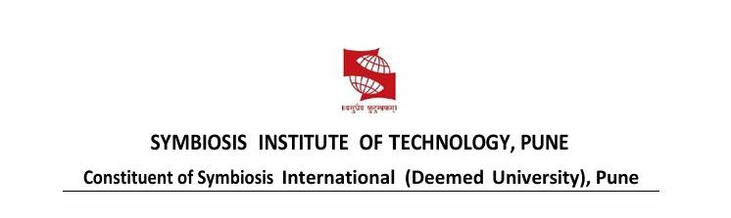
Name of Student: DAKSH JAIN PRN:25070122070
Subject: Programming with JAVA Sem: III AY: 2026-27
Assignment No: 15
TITLE: Write a Java program to demonstrate exception handling using finally, throw, and throws.

Problem Statement
Write a Java program to demonstrate exception handling using finally, throw, and throws.
Learning Objectives
To implement finally, throw, and throws for effective exception management.

Theory
The finally block always executes regardless of whether an exception occurs, making it suitable for resource cleanup. The throw keyword explicitly generates an exception, while throws declares exceptions that a method may pass to its caller. These mechanisms improve structured error handling and application stability.

Exercise
1. Create a Login program that throws an exception for invalid password and uses finally block.
import java.util.Scanner;

class LoginSystem {

static void login(String password) throws Exception { if (!password.equals("admin123")) {
throw new Exception("Invalid Password!");
}

System.out.println("Login Successful!");
}

public static void main(String[] args) {
Scanner sc = new Scanner(System.in);

System.out.print("Enter Password: ");
String password = sc.nextLine();
try {
login(password);
}
catch (Exception e) {
System.out.println("Exception: " + e.getMessage());
} finally {
System.out.println("Login process completed.");
}

sc.close();
}
}
OUTPUT:
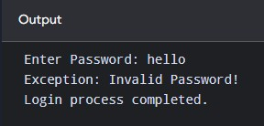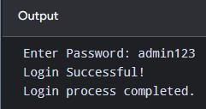

2. Create an ATM PIN Verification program that throws an exception for an invalid PIN entered by the user and uses a finally block to display a message indicating that the verification process has completed.
import java.util.Scanner;

class ATMVerification {

static void verifyPIN(int pin) throws Exception {
if (pin != 1234) { throw new Exception("Invalid PIN!");
}

System.out.println("PIN Verified Successfully!");
}

public static void main(String[] args) {
Scanner sc = new Scanner(System.in);

System.out.print("Enter ATM PIN: ");
int pin = sc.nextInt();
try {
verifyPIN(pin);
}
catch (Exception e) {
System.out.println("Exception: " + e.getMessage());
}
finally {
System.out.println("PIN verification process completed.");
}

sc.close();
}
}

OUTPUT:
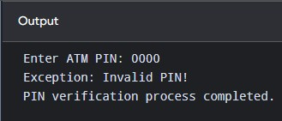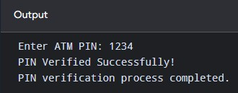
CONCLUSION:
The Java programs successfully demonstrated exception handling using throw, throws, and finally. The throw keyword was used to generate exceptions for invalid passwords and PINs, while throws declared the exceptions in methods. The finally block ensured that the verification process completion message was displayed regardless of whether an exception occurred. Thus, exception handling helps make Java programs more reliable and prevents unexpected program termination.

